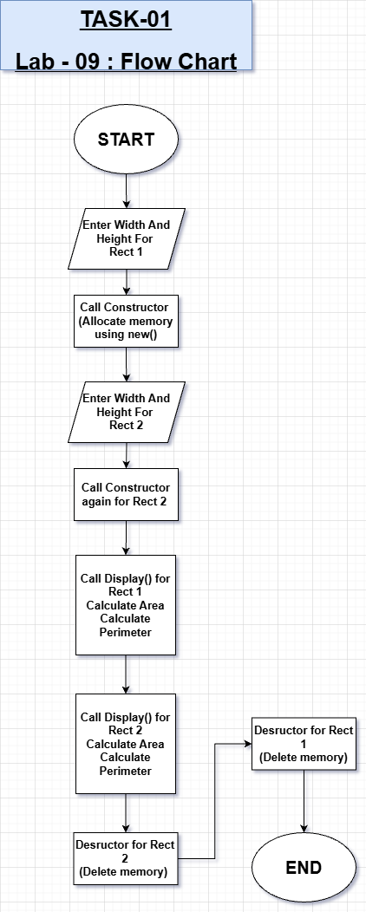
TASK#01

Task 01 – Description

This task demonstrates dynamic memory allocation using new and delete along with understanding constructor and destructor behavior.

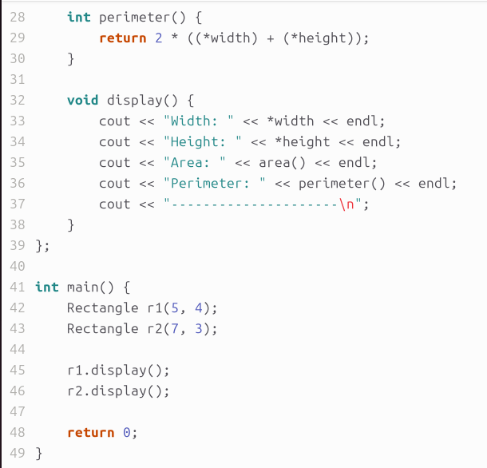
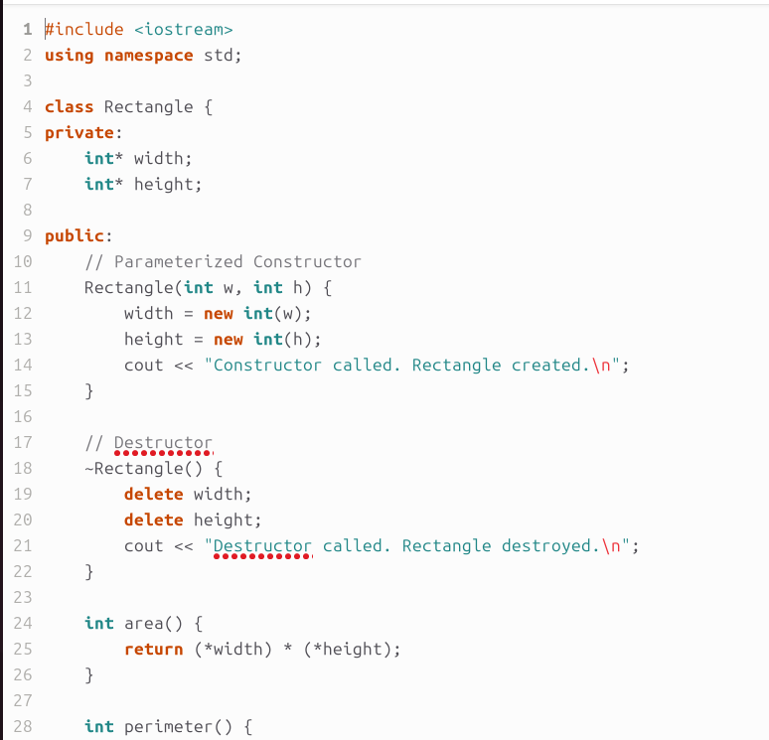
CODE

OUTPUT
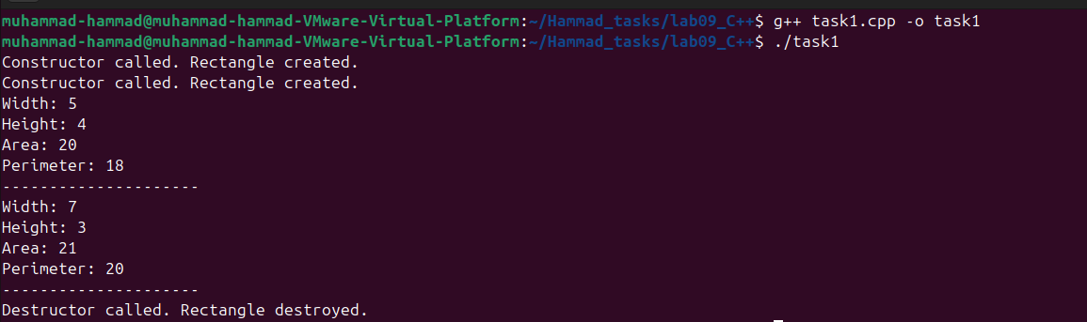
TASK#02

Task 02 – Description

It strengthens understanding of common C++ mistakes such as syntax errors, memory misuse, or incorrect declarations.

CODE SNIPPET BUGS #01

- doubleVal() modifies data members, but the object is declared Const. A const object cannot call non-const member functions.
- Const Point myPoint (5,3) here, Semicolon missing.

SOLUTION

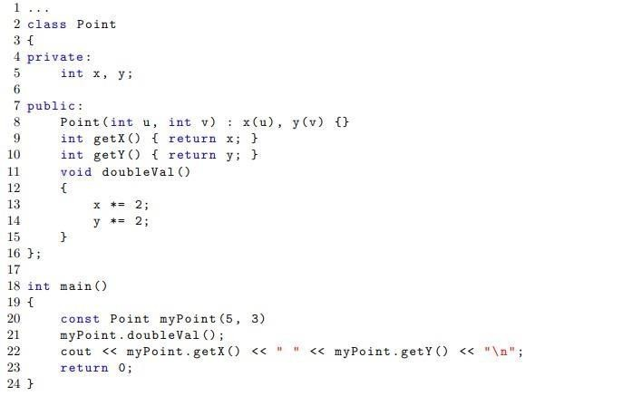
“Remove const when creating an object also add Semi colon to it.”
CODE SNIPPET BUGS #02

- A const function cannot modify member variables.
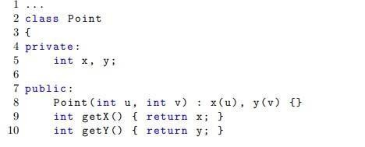
- Cout statement for space double inverted commas or single space for single inverted commas are used.(I am supposing it as a double space).

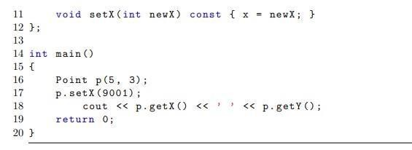
SOLUTION

- Remove const from setX function void setX (int newX) { x = newX; }.
- If cout has a single space in between the printing of X and Y then it is correct but if it is double space then it’s an error.

CODE SNIPPET BUGS #03

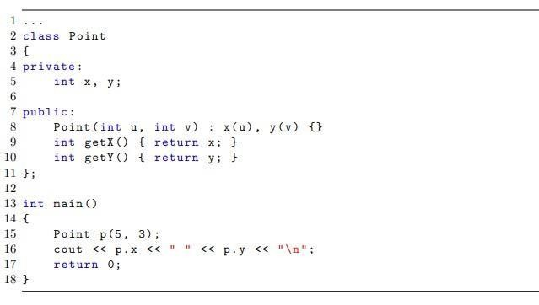
- X and Y are private. Cannot access directly outside class. cout << p.x << " " << p.y;

SOLUTION

- Use getters for private variables.

CODE SNIPPET BUGS #04

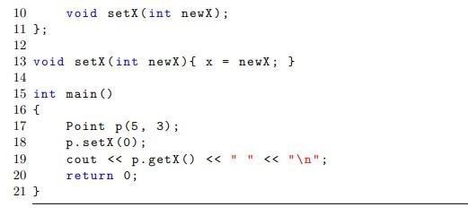
while function declared inside class, function definition must hold scope operators.

SOLUTION

When defining outside the class, you must use scope resolution operator Classname::.

CODE SNIPPET BUGS #05

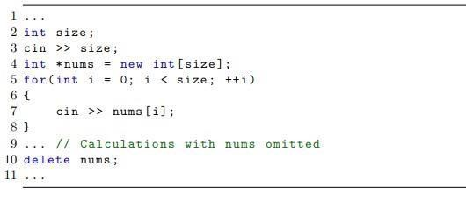
Arrays allocated with new[] is an array of size not a single variable.

SOLUTION

It must be deleted like this delete[] nums;

CODE SNIPPET BUGS #06

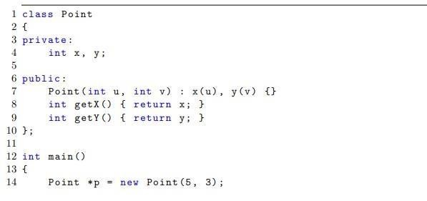
Object created with new but never deleted (memory leak).
SOLUTION

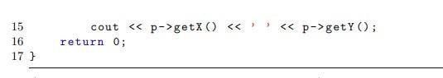
It must be deleted delete p;

Task 03 – Description

This task demonstrates advanced C++ concepts like friend functions, STL vectors, lambda expressions, and function pointers.

TASK#03

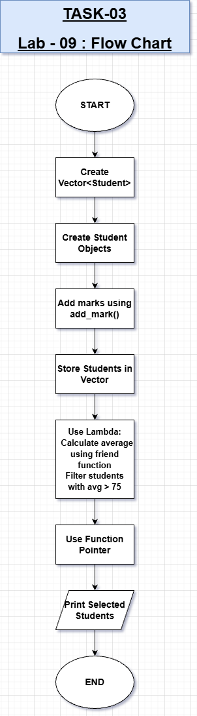

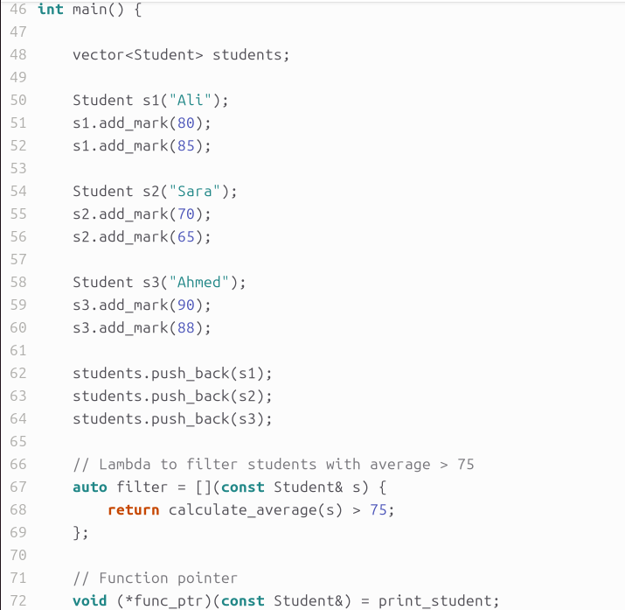
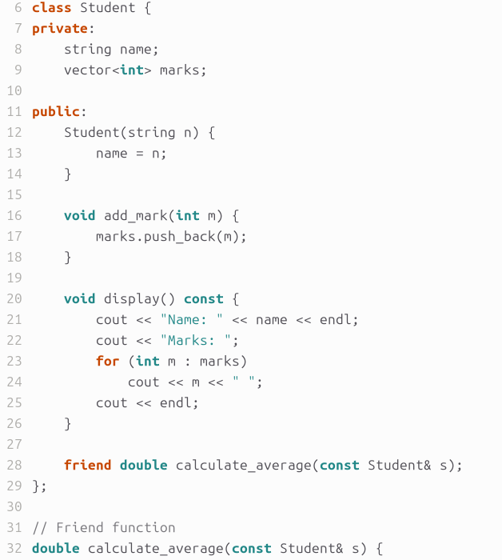
CODE

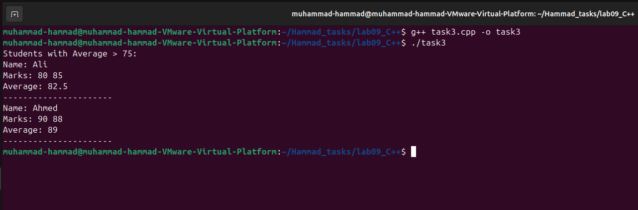
OUTPUT

CONCLUSION:

This lab enhanced our understanding of advanced C++ concepts, including dynamic memory management, constructors, and destructors. We practiced debugging skills by identifying logical and syntax errors manually. Overall, the lab improved our object-oriented programming skills and memory handling techniques.

